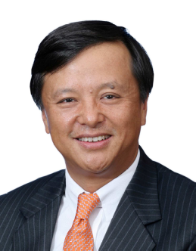

李小加
香港交易及結算所有限公司
集團行政總裁

李小加先生已於2010年1月16日接任香港交易及結算所有限公司(香港交易所)集團行政總裁一職。李先生在金融服務業擁有近20年經驗，當中包括在香港、中國內地及紐約從事企業及證券法律、企業融資及顧問服務的經驗。

加盟香港交易所前，李先生為摩根大通中國區主席。他在2003年3月加入摩根大通，總體負責摩根大通所有在華業務。

李先生又曾任職美林證券，司職美林證券中國區總裁，負責該行在華的投資銀行業務；而在1994年加入美林證券之前，李先生曾在紐約的達維 (Davis Polk & Wardwell) 與布朗伍德 (Brown & Wood) 律師事務所執業。

李先生1984年畢業於中國廈門大學，取得文學士學位；1988年獲得美國阿拉巴馬大學碩士學位；1991年取得紐約哥倫比亞大學法學博士學位。

李先生入讀大學前曾是渤海油田石油工人，1984至1986年間曾任英文《中國日報》的編輯記者。

Charles Li
Chief Executive
Hong Kong Exchanges and Clearing Limited

Charles Li became Chief Executive of Hong Kong Exchanges and Clearing (HKEx) on 16 January 2010. Mr. Li has nearly 20 years of experience in the financial services sector, including in corporate and securities law practices, corporate finance and advisory services in Hong Kong, the Mainland and New York.

Before he joined HKEx, Mr. Li was chairman of JP Morgan Chase China. He joined JP Morgan in March 2003 and was responsible for all of its China businesses. Mr. Li has also worked for Merrill Lynch and was president of Merrill Lynch China, responsible for its China investment banking operations. Before moving to Merrill Lynch in 1994, he practiced law in New York with Davis Polk & Wardwell and Brown & Wood.

He obtained a BA degree from Xiamen University of China in 1984, a MA degree from the University of Alabama in 1988 and a JD degree from Columbia University School of Law in New York in 1991.

Mr. Li worked as an offshore oil worker in the north China sea prior to college, and a newspaper editor-reporter for China Daily from 1984-1986.

